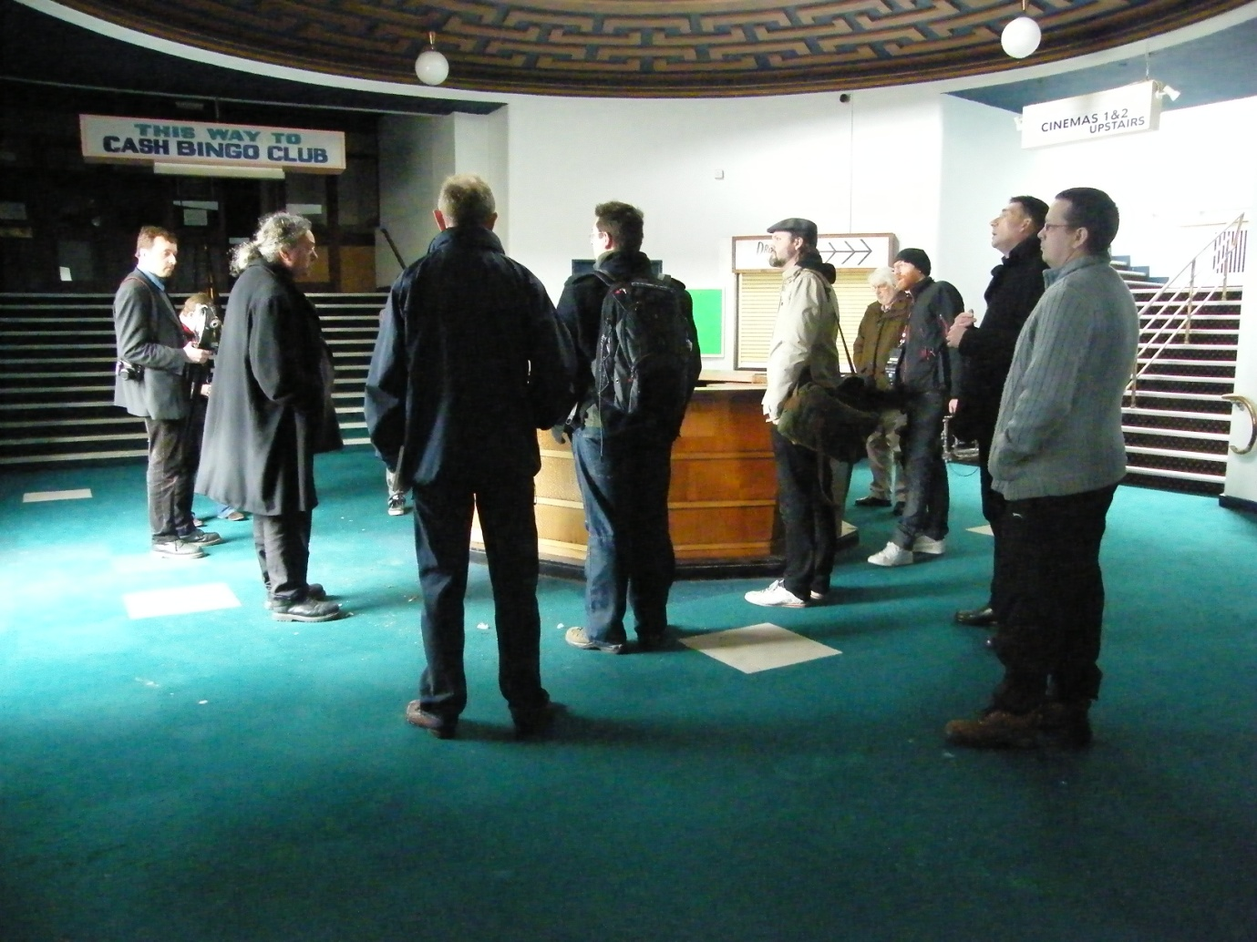
Nick Dermott, Heritage Advisor giving a historical talk to Canterbury Christ Church University photographers

DREAMLAND TEAM NEWSLETTER March 2010: Issue 1

I wanted to take this opportunity to introduce myself to Dreamland’s supporters and tell you a little bit about my role as the Audience Development Officer and some of the work the project team has been doing since coming into post at the beginning of the year.

It certainly has been busy with lots of enthusiastic enquiries about the future of Dreamland, feedback from the public about their hopes and aspirations for the project and some wonderful stories from people who have shared their Dreamland memories with us. All of these are being collected by my colleague, Graham Ward, who is starting to build the Dreamland Archive.

Some of these stories and memories will feature in an exhibition alongside extracts from Nick Evans’ book, Dreamland Remembered, as part of the Quadrophenia event at the Carlton Cinema in Westgate on 3 April, 2010. The event celebrates our popular culture and is a reminder of the historical importance of Dreamland as one of the UK’s major entertainment venues.

Tickets for the screening are selling fast, so be sure to book your place by telephoning the Carlton Cinema booking line on 01843 832019 or the Sound House in Broadsatirs on 01843 867281. For more information about the event see www.savedreamland.co.uk.

The other news is the appointment of Robert Preedy as Specialist Rides Coordinator. Bob, the author of a number of books on roller coasters and cinemas, joined the team on the 19 March 2010. His job will be to source and acquire historical rides from around the world for inclusion in the park, and to research the history of the rides we have already acquired.

Also on the 19 March I took a group of photographers from Canterbury Christ Church Univeristy in Broadstairs on visit to the site and cinema. The images produced will become part of the Archive Graham is developing and be used for future Dreamland exhibitions.

On the 24 March our Director, Jonathan Bryant and I will be attending a business breakfast hosted by the Thanet & East Kent Chamber Ltd where Jonathan will be the guest speaker. This is an ideal opportunity to promote the project and gather feedback from local businesses on the benefits of restoring Dreamland’s amusment park.

Over the next four months much of our work will be in preparation of Heritage Lottery Funding bid, which will be submitted early August. Our activities and reports will feed into the bid to help release the 2nd round of funding to bring the amusement park to fruition.

These are indeed exciting times, and I know I speak for my colleagues as well as myself when I say it is a privilage to be a part of this monumental project, which could not have happened without the dedication and commitment of those who campaigned long and hard to save Dreamland.

Jan Leandro
Audience Development Oficer
jan@dreamlandmargate.com
mobile 07932 446865

